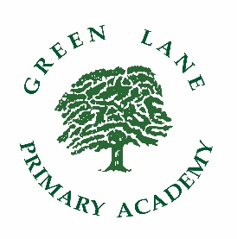
GREEN LANE PRIMARY ACADEMY

PERSON SPECIFICATION – PUPIL SUPPORT EYFS – TA2
ESSENTIAL | DESIRABLE
NVQ 2 or equivalent Teaching Assistant qualification.  Good numeracy/literacy skills including a good standard of written presentation. | Effective use of ICT to support learning and assessment.
General Knowledge of the National Curriculum/Early Years Foundation Stage Curriculum and other learning programmes/strategies. | Experience of working with children in the Early Years Foundation Stage.  Experience of planning and delivering activities within an EYFS setting.
Understanding of the principles of child development and learning.

Ability to relate well with children of the relevant age responding to particular needs and problems. | Experience of working with children who have English as an additional language.
Be able to communicate effectively with parents, carers and other professionals.

Work collaboratively as part of a team and contribute to planning and delivery of an exciting and creative curriculum.

Ability to self-evaluate learning needs and actively seek learning opportunities.  Willingness to undertake any training and or development work required of the position. | First aid qualification.
Understanding of what ‘safeguarding children’ means in the context of a primary school.

