GREEN LANE PRIMARY ACADEMY

Report to Governors and Parents on the Use of Pupil Premium

2017/18
The following outlines indicative Pupil Premium and outcomes for the financial year 17/18 and the 18/19 allocation.
This report should be read alongside the school’s Pupil Premium Policy, available on the school web site.
Overview of the School
Number of pupils and Pupil Premium Grant allocation 17/18
Total number of pupils on roll | 630 FTE
Total number of pupils eligible for PP | 100
Amount of PP received per pupil | £1 320
Total amount of PP funding received | £132 000

Support/Project | Objective | Cost | Outcomes 17/18
Two additional 0.6 teachers to teach a fourth set in Y2 and KS2 ensuring lower pupil numbers in each set | To provide higher staffing ratios in order to achieve improved outcomes for targeted pupils. | £57 701 | PP attainment in mid-year groups has been maintained or improved from Autumn 2017 to Autumn 2018. In Reading and Writing the percentage of pupils at or above age expectation is in-line with the previous year. For Maths, there is an improvement at and above age expectation.  At the end of KS1 outcomes for PP children were below Non PP children in Reading and Writing but significantly above in Maths.  At KS2, outcomes for PP children were below Non PP children in all subjects. However, outcomes in Writing were significantly above national benchmarks at 86.2% for PP.  We continue to be focussed on improving outcomes in all subjects and narrowing the gap between PP and Non PP children.
Strategic Leadership of PP Outcomes | Leadership Team/TLRs Standards and Progress to track, monitor and evaluate strategies to maximise outcomes for PP children. | £12 500
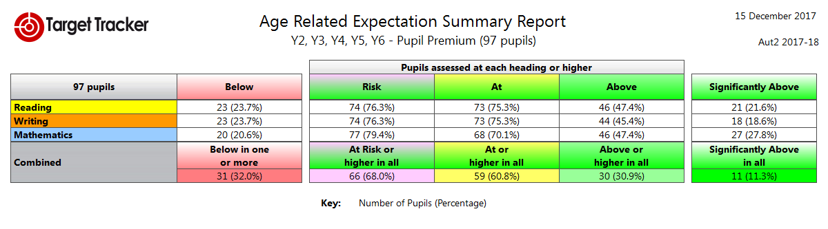
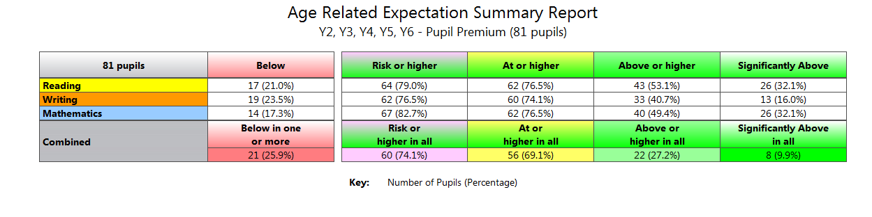Aut2 18
Provision of teaching assistant support to provide small group and individual interventions in KS1. | To improve outcomes for targeted pupils in KS1. | £13 500 | Year 1 Phonics – For the second year, Y1 PP pupils were significantly above Non PP pupils (92.9% compared to 84.9%) and 82.5% nationally.  Year 2 Phonics – PP and Non PP pupils were similar (93.8% and 95.8%) and significantly above Y2 PP pupils nationally (60.8%).  KS1 – Attainment for PP pupils in Reading (62.5%) and Writing (68.8%) were below Non PP pupils (R: 74.4%, W: 78.1%). However, the gap in Writing has closed significantly on 2017 outcomes. In Maths, PP children out-performed Non PP children – 81.3%PP compared to 74.0% Non PP.
TA to support pupils across EYFS whose language and communication skills are proving a barrier to progress. | To plan and deliver targeted support to vulnerable groups in EYFS. | £7 000 | Progress and outcomes for PP children at the end of EYFS exceeded Non PP children in all Areas of Learning (77.8% PP achieved a Good Level of Development compared to 71.1% for all pupils).
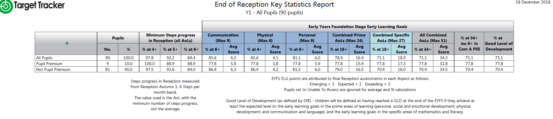
Attendance Officer Support | To improve school attendance in accordance with national benchmarks and ensure pupils are accessing learning regularly and on time. | £1 000 | PP Pupils Non PP All Pupils  R 92.8% 94.7% 94.5%  Y1 95.3% 95.6% 95.5%  Y2 95.0% 95.7% 95.5%  Y3 95.2% 96.4% 96.2%  Y4 97.2% 96.5% 96.6%  Y5 95.8% 96.5% 96.3%  Y6 94.9% 97.3% 96.5%  Attendance 2017-18  Average attendance for PP pupils compared to all pupils was similar in 2017/18 – 95.2% (PP) and 95.9% (All Pupils). Average attendance for Non PP pupils was slightly higher at 96.1%.
Release time for SENCo | To monitor intervention and outcomes of targeted groups and provide support to teachers and support staff. | £11 000 | Vulnerable groups continue to be tracked and outcomes monitored. The SENCo advises staff and manages resources including assessments for pupils with specific English and Maths needs.
Extra-Curricular Activities | To enable all pupils to access high quality educational opportunities beyond the classroom. | £1 000 | Funding has been made available to support PP children to attend extra- curricular activities and after school clubs. These experiences have a significant impact on the social skills, self-esteem and confidence of our children and this has a positive impact on learning in the classroom.
Bungalow Project Intervention | To support pupils with social, emotional and behavioural difficulties. | £6 000 | Children supported by the Bungalow Project, Educational Psychologist, Learning Mentor and PSA have benefitted significantly and are able to access learning more successfully. Parents have also been more engaged which has had a positive impact on behaviour and emotional well-being of pupils.
Additional Educational Psychologist Input | To support pupils, parents and teachers with strategies to enable the pupils to more effectively engage in their learning. | £2 700
Learning Mentor/PSA Intervention | To support pupils and their parents to engage in school and successfully access learning. | £10 785

Early Years Pupil Premium 2017/18

Number of pupils and Early Years Pupil Premium Grant allocation 17/18
Total number of pupils eligible for EYPP | 4
Amount of EYPP received per pupil | £340
Total amount of EYPP funding received | £1,360

2018/19
Allocation of Pupil Premium
The following outlines indicative Pupil Premium for the financial year 18/19.

Number of pupils and Pupil Premium Grant allocation 2018/19
Total number of pupils on roll (Reception-Y6) | 632 FTE
Total number of pupils eligible for PP | 110
Amount of PP received per pupil | £1 320
Total amount of PP funding received | £145 200

Support/Project | Objective | Cost | Outcomes 18/19
Three additional 0.6 teachers to teach a fourth set in Y2 and KS2 ensuring lower pupil numbers in each set | To provide higher staffing ratios in order to achieve improved outcomes in English and Maths for targeted pupils. | £88 281
Strategic Leadership of PP Outcomes | Co-HTs/TLRs Standards and Progress to track, monitor and evaluate strategies to maximise outcomes for PP children. | £7 600
Provision of teaching assistant support to provide small group and individual interventions in KS1. | To deliver targeted support and improve outcomes for vulnerable pupils in KS1. | £13 500
TA to support pupils across EYFS whose language and communication skills are proving a barrier to progress. | To plan and deliver targeted support to vulnerable groups in EYFS. | £6 700
Attendance Officer Support | To improve school attendance in accordance with national benchmarks and ensure pupils are accessing learning regularly and on time. | £1 500
Release time for SENDCo | To monitor intervention and outcomes of targeted groups and provide support to teachers and support staff. | £9 210
Extra-Curricular Activities | To enable all pupils to access high quality educational opportunities beyond the classroom. This will include clubs and activities after school. | £1 000
Bungalow Project Intervention | To support pupils with social, emotional and behavioural difficulties which are causing a barrier to learning. | £3 000
Additional Educational Psychologist Input | To support pupils, parents and teachers with strategies to enable the pupils to more effectively engage in their learning. | £1 600
Pastoral Lead Intervention | To support pupils and their parents to engage in school and successfully access learning. | £9 939

