GREEN LANE PRIMARY ACADEMY

Report to Governors and Parents on the Use of Pupil Premium

2018/19
The following outlines indicative Pupil Premium and outcomes for the financial year 18/19 and the 19/20 allocation.
This report should be read alongside the school’s Pupil Premium Policy, available on the school web site.
Overview of the School
Number of pupils and Pupil Premium Grant allocation 18/19
Total number of pupils on roll | 632 FTE
Total number of pupils eligible for PP | 110
Amount of PP received per pupil | £1 320
Total amount of PP funding received | £145 200

Support/Project | Objective | Cost | Outcomes 18/19
Three additional 0.6 teachers to teach a fourth set in Y2 and KS2 ensuring lower pupil numbers in each set | To provide higher staffing ratios in order to achieve improved outcomes in English and Maths for targeted pupils. | £88 281 | PP attainment in mid-year groups is broadly in-line with Non PP in all subjects and combined RWM.  At the end of KS1 in Reading, Writing and Maths, PP attainment was similar to Non PP, although in RWM combined it was lower at 50% (Non PP 66.7%)  At the end of KS2 PP outcomes were lower than Non PP:  Reading PP 61.9% Non PP 72.5%  Writing PP 71.4% Non PP 87.0%  Maths PP 71.4% Non PP 85.5%  RWM PP61.9% Non PP 69.6%  PP pupils continue to be carefully tracked as a target group across all year groups and are the focus of intervention strategies aiming for maximum progress.  Discussions at termly Pupil Progress Reviews ensure that these groups are continually tracked and monitored.
Strategic Leadership of PP Outcomes | Co-HTs/TLRs Standards and Progress to track, monitor and evaluate strategies to maximise outcomes for PP children. | £7 600
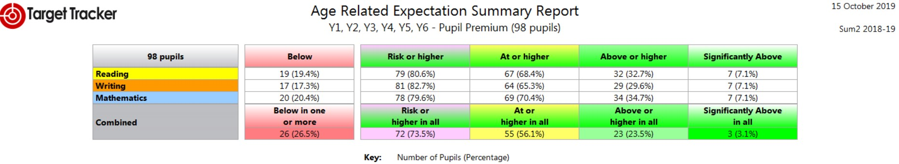

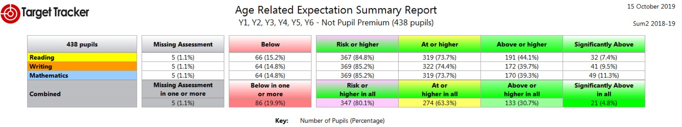

Provision of teaching assistant support to provide small group and individual interventions in KS1. | To deliver targeted support and improve outcomes for vulnerable pupils in KS1. | £13 500 | Y1 Phonics – PP pupils attainment (71.4%) was below all pupils (86.5%) and National (81.9%).  Y2 Phonics – PP attainment (100%) was slightly above all pupils996.6%) and National (92%).  Intervention strategies, including setting for Phonics, continues to have a positive impact on outcomes.
TA to support pupils across EYFS whose language and communication skills are proving a barrier to progress. | To plan and deliver targeted support to vulnerable groups in EYFS. | £6 700 | Pupils enter EYFS with starting points well below National and therefore developing Language and Communication continues to be a focus for additional support and intervention. PP outcomes at the end of Reception (66.7% GLD) were below all pupils (75% GLD) but demonstrate that the difference is diminishing.
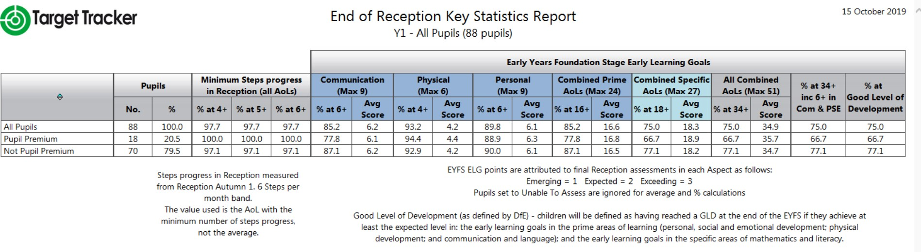
Attendance Officer Support | To improve school attendance in accordance with national benchmarks and ensure pupils are accessing learning regularly and on time. | £1 500 | PP Pupils Non PP All Pupils  R 93.3% 95.0% 94.7%  Y1 94.3% 95.8% 95.5%  Y2 96.5% 96.6% 96.6%  Y3 95.8% 96.4% 96.3%  Y4 96.1% 96.4% 96.4%  Y5 97.0% 96.9% 96.9%  Y6 95.0% 96.6% 96.2%  Attendance 2018-19
Release time for SENDCo | To monitor intervention and outcomes of targeted groups and provide support to teachers and support staff. | £9 210 | Vulnerable groups continue to be tracked and outcomes monitored. The SENCo advises staff and manages resources including assessments for pupils with specific English and Maths needs.
Extra-Curricular Activities | To enable all pupils to access high quality educational opportunities beyond the classroom. This will include clubs and activities after school. | £1 000 | Funding has been made available to support PP children to attend extra- curricular activities and after school clubs. These experiences have a significant impact on the social skills, self-esteem and confidence of our children and this has a positive impact on learning in the classroom.
Bungalow Project Intervention | To support pupils with social, emotional and behavioural difficulties which are causing a barrier to learning. | £3 000 | Children supported by the Bungalow Project, Educational Psychologist and Pastoral Lead have benefitted significantly and are able to access learning more successfully. Parents are encouraged to be more engaged which has a positive impact on behaviour and emotional well-being of pupils.
Additional Educational Psychologist Input | To support pupils, parents and teachers with strategies to enable the pupils to more effectively engage in their learning. | £1 600
Pastoral Lead Intervention | To support pupils and their parents to engage in school and successfully access learning. | £9 939

Early Years Pupil Premium 2018/19

Number of pupils and Early Years Pupil Premium Grant allocation 18/19
Total number of pupils eligible for EYPP | 3-4 (termly calculation)
Amount of EYPP received per pupil | £340
Total amount of EYPP funding received | £1,272

2019/20
Allocation of Pupil Premium
The following outlines indicative Pupil Premium for the financial year 19/120.

Number of pupils and Pupil Premium Grant allocation 2019/20
Total number of pupils on roll (Reception-Y6) | 625 FTE
Total number of pupils eligible for PP | 100
Amount of PP received per pupil | £1 320
Total amount of PP funding received | £132 000

Support/Project | Objective | Cost | Outcomes 19/20
Three additional 0.6 teachers to teach a fourth set in Y2 and KS2 ensuring lower pupil numbers in each set | To provide higher staffing ratios in order to achieve improved outcomes in English and Maths for targeted pupils. | £90 709
Strategic Leadership of PP Outcomes | Co-HTs/TLRs Standards and Progress to track, monitor and evaluate strategies to maximise outcomes for PP children. | £6 940
Provision of teaching assistant support to provide small group and individual interventions in KS1. | To deliver targeted support and improve outcomes for vulnerable pupils in KS1. | £13 500
TA to support pupils across EYFS whose language and communication skills are proving a barrier to progress. | To plan and deliver targeted support to vulnerable groups in EYFS. | £6 700
Attendance Officer Support | To improve school attendance in accordance with national benchmarks and ensure pupils are accessing learning regularly and on time. | £1 500
Release time for SENDCo | To monitor intervention and outcomes of targeted groups and provide support to teachers and support staff. | £4 731
Extra-Curricular Activities | To enable all pupils to access high quality educational opportunities beyond the classroom. This will include clubs and activities after school. | £1 000
Bungalow Project Intervention | To support pupils with social, emotional and behavioural difficulties which are causing a barrier to learning. | £2 000
Additional Educational Psychologist Input | To support pupils, parents and teachers with strategies to enable the pupils to more effectively engage in their learning. | £1 600
Pastoral Lead Intervention | To support pupils and their parents to engage in school and successfully access learning. | £3 320

